Name:



Date due:Week Beg 26th March 2018 = Compulsory Tasks

|  |  |  |
| --- | --- | --- |
| **Reading**  You should read 5 out of 7 days a week for at least 10 minutes. Parents/carers are asked to sign the record sheet each day their child reads. | **Maths/Numeracy** Follow instructions on worksheets (complete tasks for each week).  2  1  4  3 | **‘Learn Its’** Follow instructions on booklet.  1  2  3  4 |
| **Read Around the World**  Books are amazing things! They can take us to the every corner of our World and even to other planets and galaxies – Read your way around the World by finding out the setting/ country/planet of the book you are reading. Keep track of your journey in your Read Around the World Passport. How many different settings can you find? | **Be a Book face!**  Be a Book face competition – Find a book, Strike a pose and email or tweet in your picture! If you wish to take part in the competition – Entries must be in by Monday 26th March for judging. Email entries to [J.sommerville@mgfl.net](mailto:J.sommerville@mgfl.net)  More information on the back on the HLG | **Be a Carnival creator**  The Carnival of Brazil marks the beginning of Lent. Research the festival and choose an aspect of it to share with your class e.g. create a dance, make a costume or musical instrument inspired by what you have learned |
| **Be You 1!** Record an activity that you have undertaken recently and discuss the skills that you have developed whilst doing it. | **Be Creative**  **Book Mobile**  Competition time!! Create a mobile that depicts your favourite story or lots of characters from different books. Be as creative! If you would like to enter your mobile into the Book month competition – Can you please bring your mobile to school on Monday 26th March for judging. | **Be Creative**  **Create a Reading Nook**  Create a nook or corner at home that is your reading nook –  Tweet in your picture using @paradykesP #readingnook. Not got twitter – then email your picture into J.Sommerville@mgfl.net |
| **Be You 2!** Record an activity that you have undertaken recently and discuss the skills that you have developed whilst doing it. | **Be a Reader**  **100 million minutes read!**  Keep track of how much reading you do, at home, in the car, in school, on the bus, in the bath – Wherever and whenever you read count your minutes. Get someone to sign your book mark to verify your minutes!  **Bring your completed book mark in on Wednesday 28th March so we can add your minutes to the school total!** | **Be a Sharer!**  World Book day this year is about who you can share a story with. Share a story with someone over the next few weeks. Enjoy reading to someone else! |

Expectations

* Homework grid should be completed within four weeks. The **4** compulsory tasks must be completed and then you must choose **4** more additional tasks.
* Please tick the boxes once the task has been completed and then both you and a parent/carer should sign at the bottom of the page.

**Pupil Signature__________________________________ Parent/Carer Signature___________________________________**

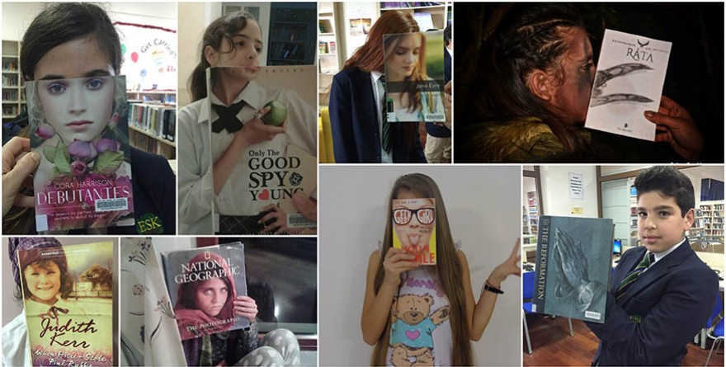

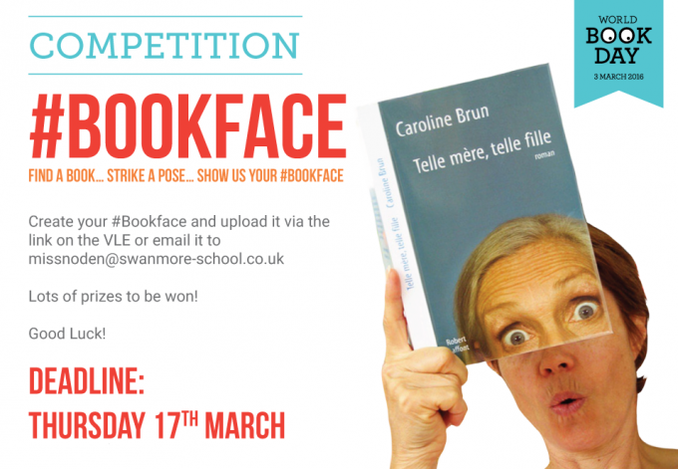

Deadline -

Monday 26th March

Prizes to be won!