Name:



Date Due: Friday 26th March = Compulsory Tasks

|  |  |  |
| --- | --- | --- |
| **Reading\*** See Reading Record. Ask an adult to ask  you questions to show your understanding of the text. | **Learn Its\***  Practise your Learn Its every Monday- Thursday at home. Ask an adult to test you.  Learn Its homework is given each week: tick the box when the tasks for each week have been completed.  1  2  3  4 | **Numeracy/Maths\*** Weekly maths task. A piece of homework will be given each week: tick the box when the task for each week has been completed.  1  2  3  4 |
| **Read Around the World**  Books are amazing things! They can take us to the every corner of our World and even to other planets and galaxies – Read your way around the World by finding out the setting/ country/planet of the book you are reading. Keep track of your journey in your Read Around the World Passport. How many different settings can you find? | **Be You** (10-15 mins)  Record a different activity that you have undertaken recently and the skill/s that you have developed whilst doing it. | **Be a Book face!**  Be a Book face competition – Find a book, Strike a pose and email or tweet in your picture! If you wish to take part in the competition – Entries must be in by Monday 26th March for judging. Email entries to [J.sommerville@mgfl.net](mailto:J.sommerville@mgfl.net)    More information on the back on the HLG. |
| **Be Creative**  **Book Mobile**  Competition time!! Create a mobile that depicts your favourite story or lots of characters from different books. Be as creative! If you would like to enter your mobile into the Book month competition – Can you please bring your mobile to school on Monday 26th March for judging. | **Be Creative**  **Create a Reading Nook**  Create a nook or corner at home that is your reading nook –  Tweet in your picture using @paradykesP #readingnook. Not got twitter – then email your picture into J.Sommerville@mgfl.net | **Be a Reader**  **100 million minutes read!**  Keep track of how much reading you do, at home, in the car, in school, on the bus, in the bath – Wherever and whenever you read count your minutes. Get someone to sign your book mark to verify your minutes!  **Bring your completed book mark in on Wednesday 28th March so we can add your minutes to the school**    **total!** |

Expectations

* Homework grid should be completed within 4 weeks.
* The compulsory tasks must be completed each week and then you can choose 3 or more additional tasks.
* There is a ‘Be You’ boxes. This can be selected as part of the 3 additional tasks if you would like to do something different to the optional tasks given above.
* Please tick the boxes once the task has been completed and then both you and a parent/carer should sign at the bottom of the page.

*\*Encourage your child to take the responsibility to find out about these tasks if they were absent on the day they were issued.*

Pupil Signature__________________________________ Parent/Carer Signature___________________________________

Emails – [L.Downie@mgfl.net](mailto:L.Downie@mgfl.net) [M.Thomson2@mgfl.net](mailto:M.Thomson2@mgfl.net)

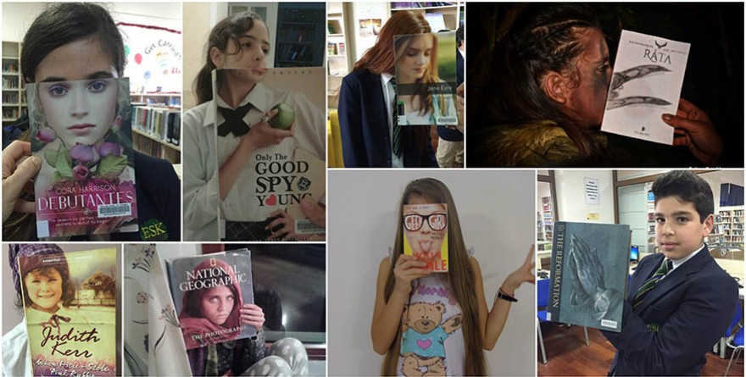

Deadline -

Monday 26th March

Prizes to be won!