Name:

Date Due: Week Beg 26th March 2018



Check dates for competitions! = Compulsory Tasks

|  |  |  |
| --- | --- | --- |
| **Reading**  * See Reading Record. | **Learn Its**   * Memorise your Learn Its for this term. | **Numeracy**  * 1-2 activities from your Maths Wall each week. |
| **Read Around the World**  Books are amazing things! They can take us to the every corner of our World and even to other planets and galaxies – Read your way around the World by finding out the setting/ country/planet of the book you are reading. Keep track of your journey in your Read Around the World Passport. How many different settings can you find? | **Be You** (10-15 mins)  Record over the page a different activity that you have undertaken recently and the skill/s that you have developed whilst doing it. | **Be a Book face!**  Be a Book face competition – Find a book, strike a pose and email or tweet in your picture! If you wish to take part in the competition – Entries must be in by Monday 26th March for judging. Email entries to [J.sommerville@mgfl.net](mailto:J.sommerville@mgfl.net)  *More information on the attached sheet. |
| **Be Creative**  **Book Mobile**  Competition time!! Create a mobile that depicts your favourite story or lots of characters from different books. Be as creative! If you would like to enter your mobile into the Book month competition – Can you please bring your mobile to school on Monday 26th March for judging. | **Be Creative**  **Create a Reading Nook**  Create a nook or corner at home that is your reading nook –  Tweet in your picture using @paradykesP #readingnook. Not got twitter – then email your picture into J.Sommerville@mgfl.net | **Be a Reader**  **100 million minutes read!**  Keep track of how much reading you do, at home, in the car, in school, on the bus, in the bath – Wherever and whenever you read, count your minutes. Get someone to sign your book mark to verify your minutes!  **Bring your completed book mark in on Wednesday 28th March so we can add your minutes to the school total!** |

Expectations

* Homework grid should be completed within 4 weeks. The compulsory tasks must be completed each week and then you can choose 3 or more additional tasks
* Please tick the boxes once the task has been completed and then both you and a parent/carer should sign at the bottom of the page.

Pupil Signature__________________________________ Parent/Carer Signature___________________________________

Remember – You need to know your Learn Its as quickly as you can say your name. Each time you practise, tick a box to the right. You should aim to practise daily and it is a good idea mix up the order when you practise.

I have practised:

**New Learn It’s for this term:**

4 + 2 = 6

5 + 2 = 7

6 + 2 = 8

7 + 2 = 9

8 + 2 = 10

9 + 2 = 11

4 + 3 = 7

5 + 3 = 8

6 + 3 = 9

Revision from P1:

**Doubles:**

1 + 1 = 2

2 +2 = 4

3 + 3 = 6

4 + 4 = 8

5 + 5 =10

Other:

2 + 1 = 3

2 + 3 = 5

**Counting in 2s and 10s**

Revision from Term 1:

**Number bonds to 10**:

1 + 9 = 10

2 + 8 = 10

3 + 7 = 10

4 + 6 = 10

5 + 5 = 10

**Counting in 5s to 50 (or beyond)**



How well do you know your Learn Its so far?

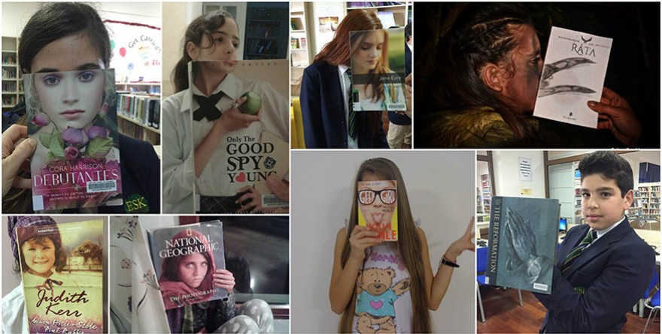

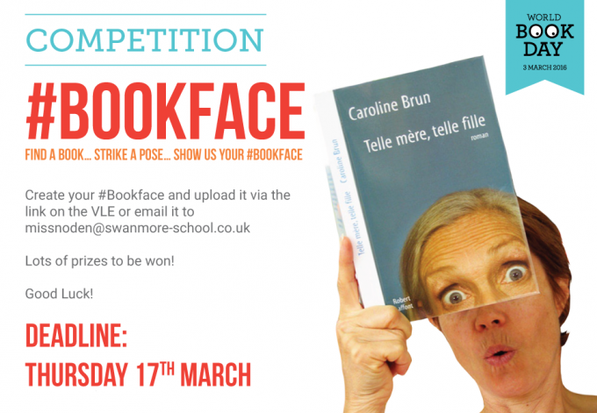

Deadline -

Monday 26th March

Prizes to be won!